Chapter 21
Taxes, Inflation, and Investment Strategy

- Moral hazard. The owner now has an incentive to cause a loss and file a claim.
- The owner will suffer from adverse selection. The owner will attract cargo that would normally cost more than the flat fee being charged.
- Passive investors who are not sophisticated and looking for reduced fees. These investors are unable to frequently review their portfolio and reallocate the investment assets. The target date fund does this automatically for the investor.
- The social security annuity is paid out for the balance of your life, regardless of how long you live. The amount is determined based on the calculation of a Primary Insurance Amount (PIA). This determines the monthly annuity paid. Like insurance, once the worker works the minimum number of years, the policy is fully paid and the recipient is guaranteed an income when reaching the designated age. There are other components of SS that are pure insurance such as survivorship benefits that are paid upon the death of a SS recipient to beneficiaries designated by law.

- The progressive tax code sharpens the importance of taxes during the retirement years. High tax rates during retirement reduce the effectiveness of a tax shelter. In the case of social security, the progressive tax code allocates a relatively larger share of retirement benefits to low-income individuals. Additionally, the lower tax brackets of a progressive system, during the retirement, years allows you to pay lower taxes over time, significantly increasing retirement consumption. The use of an IRA-style tax shelter increases the retirement annuity, thus an improvement over what you obtain from a tax shelter with the flat tax.

- With a savings rate of 16%, the retirement annuity would be $205,060 (compared to $192,244 with the 15% savings rate).
Spreadsheet 21.1: Adjusted for Change in Savings Rate
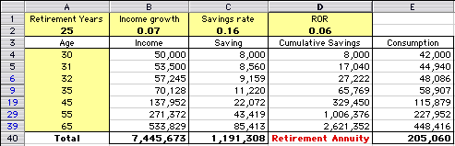
- With a savings rate of 16%, the retirement annuity will be $52,979 (vs. $49,668). The growth in the real retirement annuity (6.67%) is the same as with the case of no inflation.
Spreadsheet 21.2: Adjusted for Change in Savings Rate
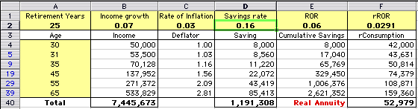

- The objective is to obtain a real retirement annuity of $49,668, as in Spreadsheet 21.2. In Spreadsheet 21.3: Backloading the Real Savings Plan, add cell F42 for the desired annuity and cell F43 for the difference between the annuity with savings from real income and the desired annuity in cell F42. Select Tools/Goal Seek from the menu bar. Set up the following parameters:
Set Cell: F43
To Value: 0
By Changing Cell: D2

Spreadsheet 21.3: With Target Cell for Desired Real Annuity
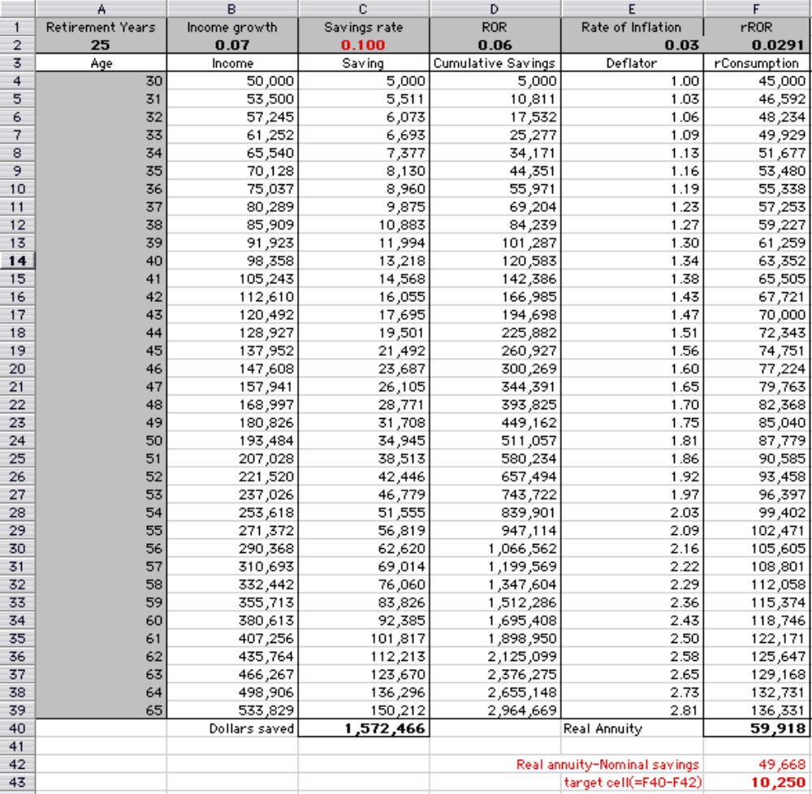

We find that a savings rate of 8.3% (C2) from real income yields the desired real retirement annuity, as the modified spreadsheet on the next page shows:
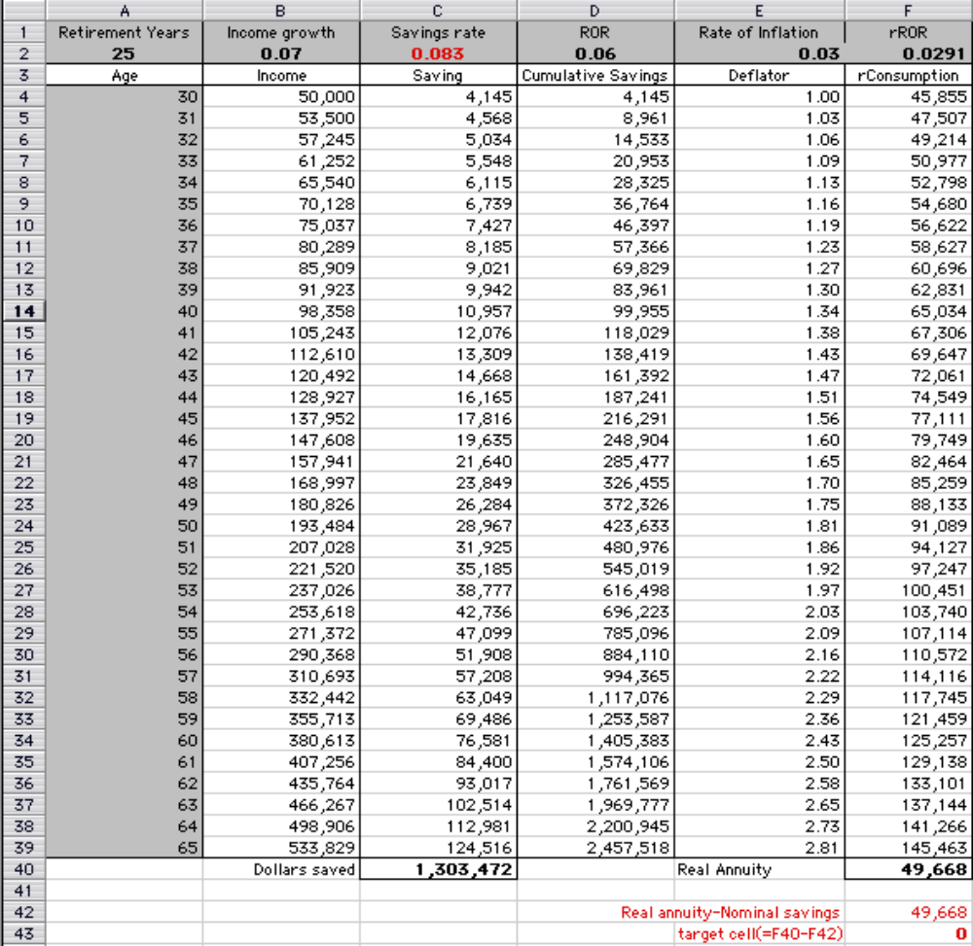

- Because of the exemption from taxable income, only part of income is subject to tax, while a change in ROR affects all savings. Because of the exemption from taxable income, only part of income is subject to tax, while ROR affects all savings.
As a result, we find from Spreadsheet 21.4 that the increase in tax rate reduces the real annuity by a relatively small amount, while the increase in ROR increases the annuity substantially. A 1% increase in the tax rate, from 25% to 26% (all else equal), reduces the real annuity from $37,882 to $37,426. A 1% increase in ROR, from 6% to 7%, increases the real annuity from $37,882 to $49,107. Making both changes simultaneously yields a real annuity of $48,505.

- In the original Spreadsheet 21.5, real consumption during retirement is $60,789. A 1% increase in the rate of inflation will reduce real consumption during retirement to $15,780.
A 1% increase in the flat-tax rate reduces real consumption during retirement to $58,983.
The root of the difference is similar to that of the case of ROR compared to tax rates. While the tax rate affects only part of the income, an increase in the rate of inflation affects all savings, and the reduction in real savings compound over time.
Note that, in this example, real consumption during the saving period is fixed, set to equal consumption in Spreadsheet 21.4. To sustain this level of real consumption with a 4% inflation rate, investors must withdraw funds from the saving account as of age 60. In reality, however, households reduce consumption in the face of deteriorating circumstances in order to protect the retirement annuity.
[See Spreadsheet 21.5 on next page.]

Spreadsheet 21.5: Adjusted for Higher Rate of Inflation
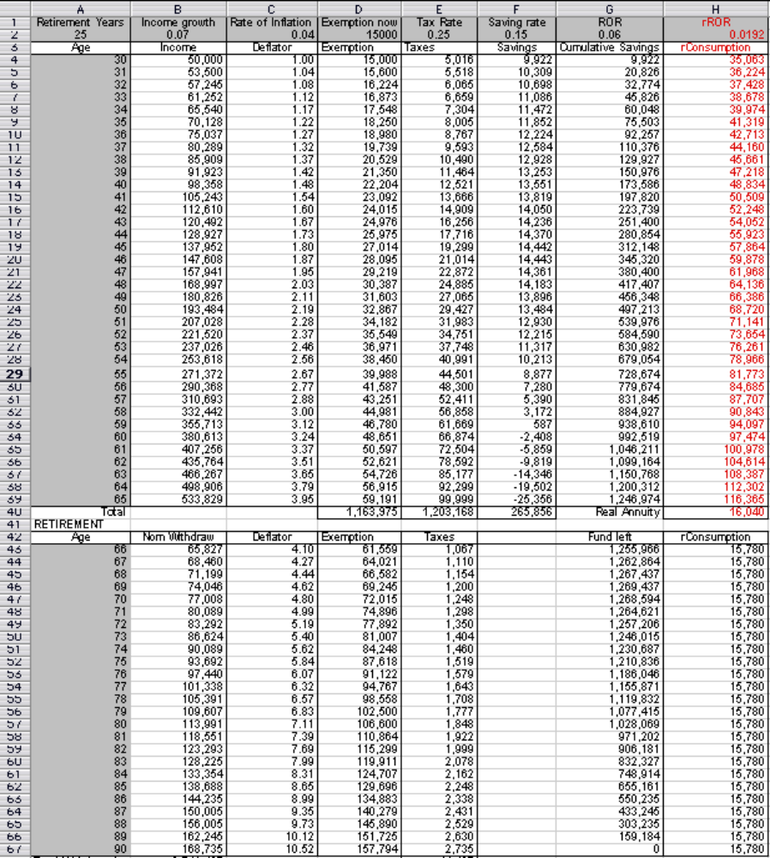

- In Spreadsheet 21.6, the real retirement annuity is $37,059.
A 1% increase in the lower tax bracket reduces the real retirement annuity to $36,815.
A 1% increase in the highest tax bracket reduces the real retirement annuity to $37,033.
The increase in the highest tax bracket has a smaller impact because it applies to a small part of income.
[Note that the adjustments to the tax rates in Spreadsheet 21.6 must be made directly in the cell formulas for Column E: Taxes.]

- The real retirement annuity in Spreadsheet 21.7 is $83,380.
A decrease of 2% in the ROR reduces the real retirement annuity to $50,900.
An increase of 2% in the ROR increases the real retirement annuity to $137,819.
The percent reduction in the real annuity resulting from the decrease in ROR (39%) is much smaller than the percent increase resulting from the increase in ROR (65%). The reason the IRA shelter works as a hedge is that, if savings decline, then the marginal tax rate declines. The reverse is true when savings increase.

- The real retirement annuity in Spreadsheet 21.8 is $ 49,153.
A 1% increase in ROR increases the real retirement annuity to $63,529.
A 1% decrease in the rate of inflation increases the real retirement annuity to $119,258.
The reason inflation is more potent than ROR is that inflation affects the entire savings. Here, too, consumption during the labor years is fixed and hence the entire effect is transferred to the retirement annuity.
Spreadsheet 21.8: Adjusted for Change in ROR
Retirement Years | Income growth | Rate of Inflation | Exemption now | Tax rates in | Saving rate | ROR | rROR
25 | 0.07 | 0.03 | 10000 | Table 20.1 | 0.15 | 0.07 | 0.0388
Age | Income | Deflator | Exemption | Taxes | Savings | Cumulative Savings | rConsumption
30 | 50,000 | 1.00 | 10,000 | 8,000 | 6,300 | 6,300 | 35,700
31 | 53,500 | 1.03 | 10,300 | 8,640 | 6,793 | 13,534 | 36,958
35 | 70,128 | 1.16 | 11,593 | 11,764 | 9,370 | 54,231 | 42,262
45 | 137,952 | 1.56 | 15,580 | 28,922 | 19,707 | 298,059 | 57,333
55 | 271,372 | 2.09 | 20,938 | 64,661 | 41,143 | 987,189 | 79,076
65 | 533,829 | 2.81 | 28,139 | 145,999 | 92,460 | 2,827,329 | 104,970
Total | 7,445,673 |  | 632,759 | 1,752,425 | 1,163,478 | Real Annuity | 63,529
RETIREMENT
Age | Nom Withdraw | Deflator | Exemption | Taxes |  | Fund left | rConsumption
66 | 184,124 | 2.90 | 28,983 | 0 |  | 2,841,119 | 63,529
70 | 207,233 | 3.26 | 32,620 | 0 |  | 2,845,645 | 63,529
75 | 240,240 | 3.78 | 37,816 | 0 |  | 2,692,973 | 63,529
80 | 278,504 | 4.38 | 43,839 | 0 |  | 2,272,075 | 63,529
85 | 322,862 | 5.08 | 50,821 | 0 |  | 1,442,043 | 63,529
90 | 374,286 | 5.89 | 58,916 | 0 |  | 0 | 63,529
Total | 6,713,023 |  |  | 0

Spreadsheet 21.8: Adjusted for Change in Inflation Rate
Retirement Years | Income growth | Rate of Inflation | Exemption now | Tax rates in | Saving rate | ROR | rROR
25 | 0.07 | 0.02 | 10000 | Table 20.1 | 0.15 | 0.06 | 0.0392
Age | Income | Deflator | Exemption | Taxes | Savings | Cumulative Savings | rConsumption
30 | 50,000 | 1.00 | 10,000 | 8,000 | 6,300 | 6,300 | 35,700
31 | 53,500 | 1.02 | 10,200 | 8,660 | 7,143 | 13,821 | 36,958
35 | 70,128 | 1.10 | 11,041 | 12,206 | 11,261 | 59,264 | 42,262
45 | 137,952 | 1.35 | 13,459 | 30,619 | 30,170 | 362,197 | 57,333
55 | 271,372 | 1.64 | 16,406 | 69,174 | 72,466 | 1,293,122 | 79,076
65 | 533,829 | 2.00 | 19,999 | 165,534 | 158,367 | 3,756,978 | 104,970
Total | 7,445,673 |  | 519,944 | 1,929,174 | 1,901,289 | Real Annuity | 119,258
RETIREMENT
Age | Nom Withdraw | Deflator | Exemption | Taxes |  | Fund left | rConsumption
66 | 243,272 | 2.04 | 20,399 | 0 |  | 3,739,125 | 119,258
70 | 263,325 | 2.21 | 22,080 | 0 |  | 3,603,662 | 119,258
75 | 290,733 | 2.44 | 24,379 | 0 |  | 3,250,278 | 119,258
80 | 320,992 | 2.69 | 26,916 | 0 |  | 2,613,730 | 119,258
85 | 354,401 | 2.97 | 29,717 | 0 |  | 1,581,215 | 119,258
90 | 391,288 | 3.28 | 32,810 | 0 |  | 0 | 119,258
Total | 7,792,077 |  |  | 0

- When deferring taxes to the last year of retirement, you must set money aside every year in order to accumulate a fund sufficient to pay the capital gains tax in a lump sum. To leave consumption fixed in real terms, a fixed real amount is set aside each year.
We calculate the cumulative capital gains in cells D45 through D69. The nominal capital gains tax due in the final year appears in cell F69, and its real value is computed in cell F71. The real annuity required in order to pay the tax in cell F71 is shown in cells I45 through I69. The real amounts set aside in cells I45 through I69 are deducted from real consumption.
With annual payments of capital gains taxes (Spreadsheet 21.9), real consumption starts at $46,808 and ends at $43,955. When taxes are deferred to the last year of retirement, real consumption is fixed at $47,206. Thus, the progressivity of the tax code makes this option preferable.
[See Spreadsheet 21.9 on next page.]

Spreadsheet 21.9: Adjusted for a lump-sum capital gains tax
Retirement Years | Income growth | Rate of Inflation | Exemption now | Tax rates in  Table 20.1 | Saving rate | ROR | rROR
25 | 0.07 | 0.03 | 10000 | Tax rates in  Table 20.1 | 0.15 | 0.06 | 0.0291
Age | Income | Deflator | Exemption | Taxes | Savings | Cumulative Savings | rConsumption
30 | 50,000 | 1.00 | 10,000 | 8,000 | 6,300 | 6,300 | 35,700
31 | 53,500 | 1.03 | 10,300 | 8,640 | 6,793 | 13,471 | 36,958
35 | 70,128 | 1.16 | 11,593 | 11,764 | 9,370 | 52,995 | 42,262
45 | 137,952 | 1.56 | 15,580 | 28,922 | 19,707 | 278,528 | 57,333
55 | 271,372 | 2.09 | 20,938 | 64,661 | 41,143 | 883,393 | 79,076
65 | 533,829 | 2.81 | 28,139 | 145,999 | 92,460 | 2,432,049 | 104,970
Total |  |  |  | 1,752,425 | 1,163,478 | Real Annuity | 49,153
RETIREMENT |  |  |  | Tax rate on capital gains |  | 0.15
Age | Nom Withdraw | Deflator | Cum cap gains | Exemption | Taxes | Fund left | rConsumption | Savings* | Adj.  rConsumption
66 | 142,460 | 2.90 | 1,414,494 | 28,983 | 0 | 2,435,512 | 49,153 | 1,947 | 47,206
70 | 160,340 | 3.26 | 1,997,710 | 32,620 | 0 | 2,404,847 | 49,153 | 1,947 | 47,206
75 | 185,879 | 3.78 | 2,702,767 | 37,816 | 0 | 2,233,096 | 49,153 | 1,947 | 47,206
80 | 215,484 | 4.38 | 3,332,479 | 43,839 | 0 | 1,846,348 | 49,153 | 1,947 | 47,206
85 | 249,805 | 5.08 | 3,811,381 | 50,821 | 0 | 1,146,895 | 49,153 | 1,947 | 47,206
90 | 289,593 | 5.89 | 4,030,524 | 58,916 | 629,410 | 0 | 49,153 | 1,947 | 47,206
Total |  |  |  | 1,056,691 | 629,410
 |  |  |  | real taxes = | 106,832
*Savings needed to pay taxes at end of retirement period (in real terms)

- Answers will vary.

- The present value of labor income is $ 2,010,917 (at the rate of the applicable ROR). The present value of college tuition is $167,741. This is equal to:

($167,741/$2,010,917) = 8.34% of the present value of labor income. When college tuition increases by 1%, to $40,400, the present value of college tuition increases to $169,419, which is equal to 8.42% of labor income. Note that the present value of college tuition for two children makes up almost 10% of the present value of the entire household lifetime income.
[See Spreadsheet 21.10 on next page.]
Spreadsheet 21.10: Adjusted for 1% increase in college tuition
Retirement Years | Income growth | Rate of Inflation | Savings rate | ROR | rROR | Extra-Cons
25 | 0.07 | 0.03 | 0.15 | 0.06 | 0.0291 | 40,400
Age | Income | Deflator | Saving | Cumulative Savings | rConsumption | Expenditures
30 | 50,000 | 1.00 | 7,500 | 7,500 | 42,500 | 0
31 | 53,500 | 1.03 | 8,025 | 15,975 | 44,150 | 0
35 | 70,128 | 1.16 | 10,519 | 61,658 | 51,419 | 0
36 | 75,037 | 1.19 | 11,255 | 76,613 | 53,416 | 0
37 | 80,289 | 1.23 | 12,043 | 93,254 | 55,490 | 0
38 | 85,909 | 1.27 | 12,886 | 111,735 | 57,645 | 0
39 | 91,923 | 1.30 | 13,788 | 132,228 | 59,884 | 0
40 | 98,358 | 1.34 | 14,754 | 154,915 | 62,209 | 0
41 | 105,243 | 1.38 | 15,786 | 179,996 | 64,625 | 0
42 | 112,610 | 1.43 | 16,891 | 207,688 | 67,135 | 0
43 | 120,492 | 1.47 | 18,074 | 238,223 | 69,742 | 0
44 | 128,927 | 1.51 | 19,339 | 271,855 | 72,450 | 0
45 | 137,952 | 1.56 | 20,693 | 308,859 | 75,264 | 0
46 | 147,608 | 1.60 | 22,141 | 349,532 | 78,187 | 0
47 | 157,941 | 1.65 | 23,691 | 394,195 | 81,223 | 0
48 | 168,997 | 1.70 | 25,349 | 374,418 | 84,378 | 68,778
49 | 180,826 | 1.75 | 27,124 | 353,165 | 87,654 | 70,842
50 | 193,484 | 1.81 | 29,023 | 257,444 | 91,058 | 145,934
51 | 207,028 | 1.86 | 31,054 | 153,633 | 94,595 | 150,312
52 | 221,520 | 1.92 | 33,228 | 118,668 | 98,268 | 77,411
53 | 237,026 | 1.97 | 35,554 | 81,609 | 102,084 | 79,733
54 | 253,618 | 2.03 | 38,043 | 124,549 | 106,049 | 0
55 | 271,372 | 2.09 | 40,706 | 172,727 | 110,167 | 0
56 | 290,368 | 2.16 | 43,555 | 226,646 | 114,446 | 0
57 | 310,693 | 2.22 | 46,604 | 286,849 | 118,890 | 0
58 | 332,442 | 2.29 | 49,866 | 353,926 | 123,507 | 0
59 | 355,713 | 2.36 | 53,357 | 428,519 | 128,304 | 0
60 | 380,613 | 2.43 | 57,092 | 511,322 | 133,286 | 0
61 | 407,256 | 2.50 | 61,088 | 603,090 | 138,462 | 0
62 | 435,764 | 2.58 | 65,365 | 704,639 | 143,840 | 0
63 | 466,267 | 2.65 | 69,940 | 816,858 | 149,426 | 0
64 | 498,906 | 2.73 | 74,836 | 940,705 | 155,229 | 0
65 | 533,829 | 2.81 | 80,074 | 1,077,222 | 161,257 | 0
Total |  |  | 1,116,851 | Real Annuity | 21,771
Present value of labor income = |  |  | 2,010,917
Present value of college tuition = |  |  | 169,419
PV(college tuition)/PV(labor income)= |  |  | 8.42%

- Adverse selection is a concept that is generally associated with insurance; however, in a broader sense, adverse selection is a potential issue in any contract where one party has more complete information about the transaction than the other. In insurance, the insured has more information about one’s own health (e.g., in life insurance and health insurance) or, in general, the risk of loss (e.g., one’s driving ability in the context of automobile insurance). The insurance company attempts to price an insurance contract based on the average characteristics of a population, but, in the case of life insurance, for example, those whose health is worse than average are more likely to buy the policy that is priced in terms of the company’s average risk of loss because this price is a bargain for the person with above-average risk. On the other hand, the person in good health will regard the price of such a contract as too high and will not buy the insurance. The consequence for the insurance company is that those who buy the contract are higher risks than average, resulting in higher losses for the insurance company. Insurance companies try to resolve such problems by measuring the risk (e.g., requiring medical examinations before issuing an insurance policy) in order to price the insurance contracts correctly. In the broader economic sense, adverse selection affects product prices because the seller of a product knows more about the quality of the product than does the buyer. The buyer may tend to assume that the quality is worse than it actually is, and may not be willing to pay the high price that would be appropriate for a high-quality product. The seller is then forced to reduce both the price and the quality of the product.

- The major traits are the degree of risk aversion and the bequest motive.

- In general, moral hazard is a term associated with insurance contracts and with government programs that essentially function as insurance. When an individual or a business entity insures against loss of property due to fire, theft or other hazard, the insured may have a tendency to take greater risks than one would in the absence of insurance. In the extreme, the insured may be motivated to damage or destroy one’s own property in order to collect payment from the insurer. Even health insurance might lead the insured to be less cautious about one’s health. In addition, the existence of government programs that provide assistance to those in poverty or those who have suffered a loss due to natural disaster may encourage those at risk to be less attentive to these risks. Examples include unemployment compensation, food stamps and public housing which serve as a form of insurance against financial difficulties. Also, government disaster relief programs may serve to encourage people to live in disaster-prone locations. Similarly, government bailouts of financial institutions and other corporations may also encourage risky behavior.

